|  |
| --- |
|  |

|  |
| --- |
| **Financial Plan for Richard Rollover** |
|  |
|  |
|  |
|  |
| **By Tomasz Luty** |
| **2/19/2015** |
|  |

List of contents:  
  
I. Introduction  
II. Asset & Liabilities  
III. Goals and Objectives  
IV. Income and Expenditure  
V. Recommendations  
VI. Quick Action Plan  
VII. List of Appendices  
VIII. List of References

I. Introduction

I am pleased to introduce this financial plan for Mr Richard Rollover. You have requested his wife, Beth, to be included in this plan as well. From the fact-find, I see that you are currently 46 years old and employed at Lloyds Bank. Considering your age, there is a increasing concern about retirement planning. From the research there is a trend, that individuals would like to live on 75% of income when they were employed. The plan has been divided into stages to help you understand the process as well as produce suitable outcomes without impairing client’s current lifestyle.   
 According to the Monetary Policy Committee Minutes Report (2015), current investing environment shows strong position on the UK and Swiss market. Eurozone keeps relatively strong position, however due to struggle towards meeting the inflation target, therefore it is considered more risky. Bank of England has announced on 18.02.2015 to keep its lending rate at 0.5% and short term rate at 0.75%.

II. Asset & Liabilities

1st stage of the financial planning process is to do an asset and liabilities analysis, which will determine where you are in terms of your financial position. From the details provided during the fact –find process the net worth analysis has been produced under following analysis:   
  
Table 1: Assets and liabilities

|  |  |  |  |
| --- | --- | --- | --- |
| Assets |  |  |  |
| item | self | joint | wife |
| house |  | £340,000 |  |
| contents |  | £25,000 |  |
| bank accounts |  | £1,000 |  |
| Isa | £22,000 |  | £13,000 |
| car | £15,000 |  | £5,000 |
| payout due | £300,000 |  |  |
| subtotal | £337,000 | £366,000 | £18,000 |
| total |  |  | £721,000 |

|  |  |  |  |
| --- | --- | --- | --- |
| Liabilities |  |  |  |
| item | self | joint | wife |
| mortgage |  | £120,000 |  |
| total |  |  | £120,000 |

|  |  |
| --- | --- |
| net worth | £601,000 |

Pension assets: If you would retire today your pension income would be valued with the data provided below:

|  |  |  |
| --- | --- | --- |
| Pension assets | self | wife |
| accrual rate | 60th |  |
| retirement age | 65 |  |
| contract in/out | in |  |
| years in scheme | 25 |  |
| contribution | 10% |  |
| yearly contribution | 6100 |  |
| death in service | 4*salary |  |
| spouse pension in service | 25% salary |  |
| spouse pension in retirement | 50% |  |
| escalation rate | RPI |  |
| current RPI | 1.1% |  |
| pension value [appendix 3] | £635,400 | £317,700 |

From the above calculations and assuming the data provided is accurate and up to date, you are in good financial position having £601,000 of surplus assets in possession along with your spouse. In addition to that you have quite significant pension assets, but they are excluded because they are not easily releasable.

III. Goals and Objectives

From what I was told, goals and objectives of Rollovers are summarised with order of importance as following:

1. Investment planning and management:  
 Your current age suggests increased concern towards investing towards his retirement, which means looking for balanced risk asset types, which would provide relatively good level of return

2. Retirement planning:  
 You have specified that you wants to maintain the current financial standard when he retires. To do so we need to analyse current expenditure profile.

3. Family security:   
 The Client specified that he wants to protect his family against the disability and death of either him or his wife. To do so, we might look into suitable insurance policies.

4. Education expenses:  
 Children are currently 18 and 14 years old.

5. Savings from income:  
 You have specified that You are not sure about how much of disposable income You may have. To do so we have to match Your income against expenditures, which will determine the surplus that may be useful towards investment portfolio

6. Estate planning:   
I would suggest setting up a trust and a will, which could prevent of any unexpected events in case of your or spouse’s death.

IV. Income and Expenditure

The next step in your plan is the income and expenditure comparison, which I summarised with a graph below:

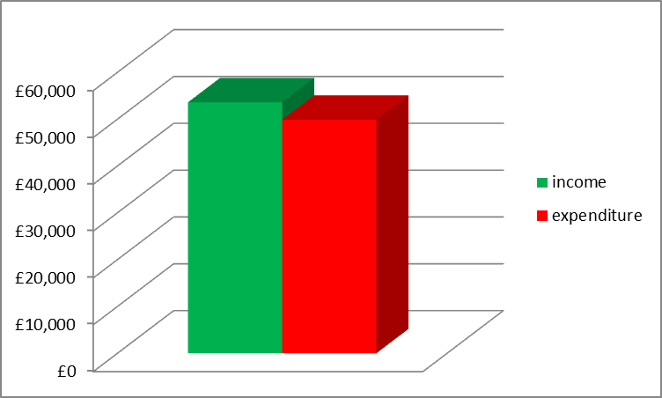

Your expenditure is outlined with a chart:  
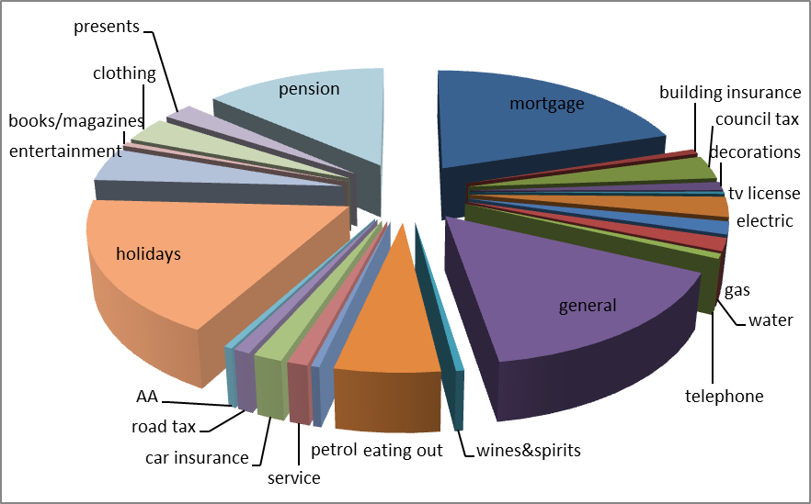  
  
There is one thing in your expenditure profile, that comes on the 1st plan, which is your **mortgage payment**. However the good news is, that you and your wife have **surplus income** of **£3,726** which can be either saved or invested.

However the cashflow includes school fees for children It is presented below   
 (Voyant)

And indicates that primarly you are in a good financial position and basically does not require to adjust anything in your financial profile. However, there are key issues that are specified in the recommendations section.

V. RecommendationsRecommendations list is a guidance to increase maximise your personal finance potential without impairment on your current lifestyle. Please note, that this is only advisory and you are not required to take any action. The list of the actions is specified below:

**Pay off liabilities:**

Firstly, to maximise your income potential, the payout of £300,000   
could be used against your liabilities. As a result your surplus income would increase from £3,726 to £12,726.

**Investment and Retirement Planning:**

In relation to your goals and objectives, we have to set up a right investment strategy for you. The investment profile for you is based on your goals and objectives To help you understand how the risk and return theory I found a simple graph explaining what sort of return and risk are provided by different asset classes:  
   
(Monevator, 2015)   
  
 Your objectives suggest that your expenditure indicates you need some money immediately to pay school fees for children, and according to my research the average yearly cost of education in London is £10,133. It has been included in the primary cash flow. Although, the cash flow suggests that you may struggle if you do not invest any of your money and will just leave the situation as it is, you may run out of money at around age 80.   
 Coming towards how you should invest your money, for short term goals you should invest in relatively liquid short term assets and analysing your risk profile, for Beth I suggest investment in government and corporate bonds would be the best option, however property could be a reasonable option as well.

Considering the £180,000 you have left after paying off the mortgage I would suggest putting more of the investment money into the Beths account, either £120,000 or £90,000. The strong reason for that is tax efficiency and that comes to area of income tax and Inheritance tax as well. At the moment you are a higher band taxpayer which in terms of investment returns makes your position quite unattractive because of the tax, that may tail your investments. Let this quick example show you how the ownership pattern could help you dividends using an example of £100,000:  
  
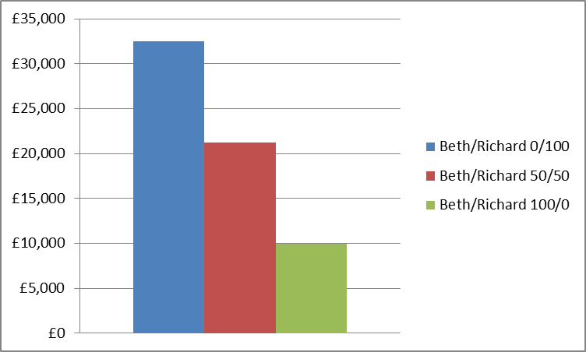  
  
The most reasonable solution for you would be to split investments balanced at 50/50. The most efficient, however, would be if Beth would own all the investment portfolio as the difference, in this case, is £22,500. You could protect your investments using a discretionary trust. The proposal is to split the investments ownership of 50/50  
  
 **Choosing the right investment portfolio:**You need to be advised that investments are exposed to risk and because of the market performance, they may go up and down depending on the situation on the market. **Beth [£90,000]:**  
 Considering the fact that Beth is a moderate risk taker I would suggest taking an investment fund with medium exposure to risk:  
  
(Hargreaves and Lansdown, 2015)

To give you some figures the Newton, Mutual and Lindsell have performed as following:

Newton:  


Lindsell:  


Mutual: 

Average of the 3 combined in the last 5 years is 46.7% and investing £50,000 5 years ago would return you about £25,000 today.

**Richard [£90,000]:** Your risk profile suggests you’re capable to take high risks and therefore I suggest you should investment portfolio that may give you relatively high return. I have looked for a suitable investment portfolio which is summarised below:  
  
(Hargreaves and Lansdown, 2015)

The Threadneedle European Select has performed as following:  
  


and the Old Mutual UK Alpha:  
  
  
The return of these 2 combined has resulted at 91% average, which in £50,000 investment would almost bring the same amount as a return.  
  
There is an exposure to emerging market markets as well, although they are too volatile to provide stable growth which has to be assured for you towards retirement.   
  
The current investments you have are ISAs of £22,000 and £13,000. What I suggest you should do is to make **emergency fund** in form of easy access savings account for them so you can have quick cash in case you may need it for.

As your objective primarly is to have an established investment profile, I suggest to merge those 2 so your investment portfolio can achieve the return that is essential for top up of your cashflow.  
However, let’s do some quick overview of how your retirement looks like at the moment, underlining key points and assuming no change will commence in your expenditure:

* Your pension income should be £40,667 pa. plus state pension for a couple, and as your pension includes 50% spouse pension, she would receive £20,333 pa.,
* Using that option you can keep your current financial standard, however the pension is in your name and you die, all of the pension income that is paid out because of your service, will simply stop being paid out.

That is why investment planning should correlate with **protection.** I do suggest that because you are a high earner, you must protect your income and your life against unexpected circumstances like loss of the job, disability, or death. I have considered all those 3 options and provided a simulation that may show you what is going to happen if you do not protect yourself.  
Let’s consider you don’t do anything and die in 15 years time:  
  
  
[voyant]

The good news is, the life of your wife would not be as much impaired and the return you would have to achieve could be already achieved with the investment portfolio.

However, what would happen if you died today, tomorrow, or next week?  
  
Immediately, all of your pension would be seized and all what you would have is 4 x salary as a death in service, or simply nothing if it would happen.

Consider you become disabled and unable to work, and you may see a financial disaster inside your own family…  
  
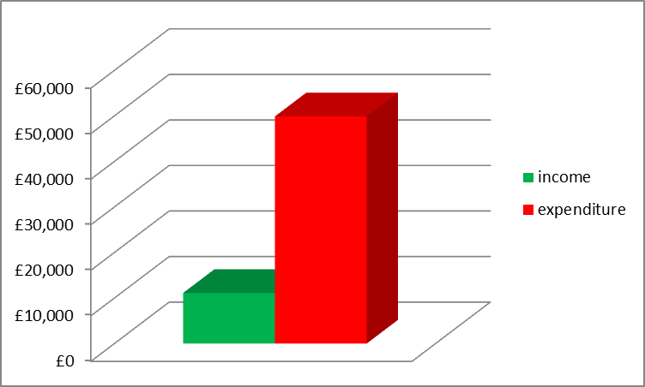  
In such case your family will suffer a massive income shortfall which will impair their lifestyle, may lead into loss of your house, bankruptcy, uneducated children…..   
  
That’s the main reason why you need protection. You need to protect against what can go wrong so you can invest in what can go right.   
I suggest as you are high earner you should insure yourself with income protection and life insurance with Critical Illness addition.

Please find the policies I have chosen for you:

Income protection from Liverpool Victoria:

(GoCompare, 2015)

Reasons why it would be the best cover is because it protects you against sickness as well as redundancy.

Life insurance & critical illness:  
 As a second line of defence I suggest that you should obtain a life insurance with critical illness policy, which would benefit you in case you would not be able to return to work after certain time or not able to return to work compeletely.   
  
(GoCompare, 2015)  
  
Aviva is one of the biggest insurance providers in UK and throughout Europe. I think £250,000 should be enough for you in case of death so that Beth can use the payout to buy an annuity. The reason for this is because your pension is linked to you and does not specify whether it is being paid out in case of your death. I assume the pension payment seizes in such case.   
Considering the worst scenario, when both of you would die, your children would inherit all your physical assets, and pension and investment assets. That’s where **estate planning** comes in place.   
Earlier suggestion was to split the investment payout into half to provide reasonable balance between ownership pattern and taxation. However, if you wish to make any further changes, please feel free to let me know. However, I considered that you should protect them with a **trust** in case you or your wife would die, your children education would still be able to be funded.  
Apart from trust, not immediate, but further options can be provided and that is where **will** comes in place. Although, the decision of **how the assets should be split is left to you.** You have also told that you want to work around savings from your income. Let us have a quick view on how your expenditure would be after all alterations:

+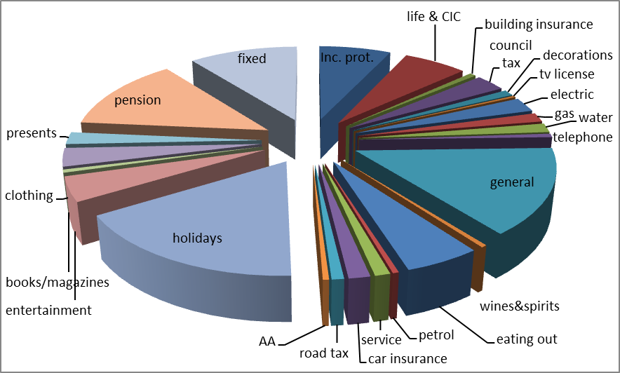  
**surplus income: £6,503.**

Analysing the expenditure, you cannot do very much around it. The only thing you could would be try to find cheaper holidays.  
  
The surplus £6,503 you have can be invested additionally into Beths pension pot as despite having your option, she could be having something in case your pension would stop or in case you get divorced.   
  
  
  
  
  
  
  
  
  
  
  
  
VI. Quick Action Plan  
  
  
**To summarise, here is a short version of your financial plan:  
  
income: surplus of £3,726  
  
Immediate actions to be taken:  
1. Set up emergency fund  
2. Pay off the mortgage  
3. Invest the rest of the payout in investment portfolios   
4. Buy protection  
  
Non-priority actions:  
1. Set up a trust  
2. Set up a will  
3. Work around cheaper holidays  
4. Invest the surplus income into Beths Pension Pot.**

VII. List of Appendices

Appendix 1: Expenditure breakdown:

|  |  |  |
| --- | --- | --- |
|  |  | annual expenditure |
| item class |  |  |
| house | mortgage | £9,000 |
|  | building insurance | £300 |
|  | council tax | £1,400 |
|  | decorations | £500 |
|  | tv license | £145 |
| utilities | electric | £1,200 |
|  | gas | £750 |
|  | water | £750 |
|  | telephone | £300 |
| housekeeping | general | £7,000 |
|  | wines&spirits | £200 |
|  | eating out | £2,500 |
| motor | petrol | £200 |
|  | service | £500 |
|  | insurance | £700 |
|  | road tax | £400 |
|  | AA | £200 |
| travel/leisure | holidays | £8,000 |
|  | entertainment | £2,000 |
|  | books/magazines | £250 |
| personal | clothing | £1,500 |
|  | presents | £1,000 |
|  | insurance | £6,100 |
|  | total | £44,895 |

Appendix 2: risk capacity summary:

|  |  |  |  |  |  |
| --- | --- | --- | --- | --- | --- |
| Risk attitude & | Retirement | Long term | Medium term |  | Short term |
| investment/ | (pension | investment | investment & |  | savings up to 5 |
| asset type | schemes) | over 15 years | savings 5-15 |  | years |
|  |  |  | years |  |  |
| No risk to |  |  |  |  | Both |
| capital |  |  |  |  |  |
|  |  |  |  |  |  |
| Low risk |  |  |  |  |  |
|  |  |  |  |  |  |
| Modest risk | Both | Beth | Beth |  |  |
|  |  |  |  |  |  |
| Relatively |  | Richard | Richard |  |  |
| higher risk |  |  |  |  |  |
|  |  |  |  |  |  |
| High risk |  | Richard | Richard |  |  |
|  |  |  |  |  |  |

Appendix 3: Pension value [using <http://www.telegraph.co.uk/finance/personalfinance/pensions/11230612/Calculator-final-salary-pension-valuation.html>]   
  


Appendix 4: Altered expenditure after paying the mortgage out and added protection policies:

|  |  |
| --- | --- |
| Inc. prot. | £3,310 |
| life & CIC | £2,913 |
| building insurance | £300 |
| council tax | £1,400 |
| decorations | £500 |
| tv license | £145 |
| electric | £1,200 |
| gas | £750 |
| water | £750 |
| telephone | £300 |
| general | £7,000 |
| wines&spirits | £200 |
| eating out | £2,500 |
| petrol | £200 |
| service | £500 |
| car insurance | £700 |
| road tax | £400 |
| AA | £200 |
| holidays | £8,000 |
| entertainment | £2,000 |
| books/magazines | £250 |
| clothing | £1,500 |
| presents | £1,000 |
| pension | £6,100 |
| fixed | £5,000 |
| total | £47,118 |

VIII. List of References

1. Monevator.com (2012) A quick guide to asset classes. *Monevator* [online]. Available from:   
   <http://monevator.com/asset-classes/> [Accessed 24.02.2015]
2. Monetary Policy Committee ( 2015) Minutes of the Monetary Policy Committee Meeting, 4 and 5 February 2015. *Monetary Policy Committee* [online]. Available from <http://www.bankofengland.co.uk/publications/minutes/Documents/mpc/pdf/2015/feb.pdf> [Accessed 26.02.2015]
3. Hargreaves and Lansdown (2015) Master Portfolios – Ready made investment portfolios. *Hargreaves and Lansdown* [online]. Available from:  
   <http://www.hl.co.uk/funds/master-portfolios> [Accessed 27.02.2015]